EC 109
Harmonised application form (1)
Очистить анкету
Инструкция в формате pdf

1 |  |  |  |  |  |  | Date of application:  Visa application number:  Application lodged at Embassy/consulate CAC  Service provider Commercial intermediary Border  Name:  Other  File handled by:  Supporting documents: Travel document Means of subsistence Invitation  Means of transport TMI  Other:  Visa decision: Refused Issued:  A C  LTV  Valid From
2
3
4 |  |  | 5 |  | 7
 |  |  | 6
8 |  | 9
10
11
12 | Дипломатический паспорт Другой проездной документ (указать, какой именно):
13 |  | 14 |  | 15 |  | 16
17
18

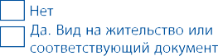
*19
*20
 |  |  |  |  |  |  | Until
21
 |  |  |  |  |  |  | Number of entries: 1 2  Number of days: | Multiple
(1) No logo is required for Norway, Iceland and Switzerland.
Следующая страница

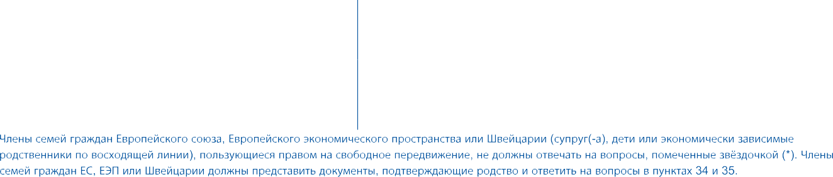
25
24
23
22

26
27

28

29 | 30
*31
*32
*33
 | 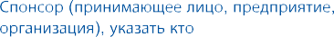

Следующая страница

34
 | 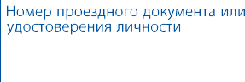
35
36 |  | 37
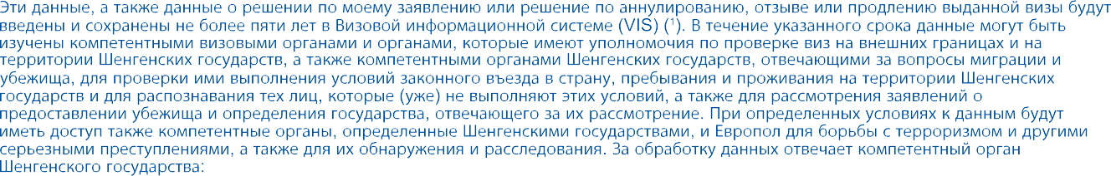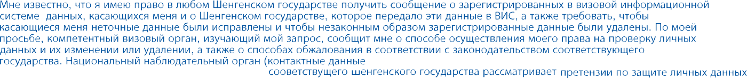
Министерство иностранных дел Финляндии, PO Box 176, 00023 Government, Finland, адрес электронной почты:
visas.passports@formin.fi
Office of the Data Protection Ombudsman, PO Box 315, 00181 Helsinki,
Finland, адрес электронной почты: tietosuoja@om.fi)

(за несовершеннолетних подписывает законный представитель; родитель, усыновитель,опекун или попечитель)
(1)
На первую страницу
Распечатать

